THEORY QUESTIONS
1.
Study Figure 1 carefully and use it to answer questions (a) and (e)
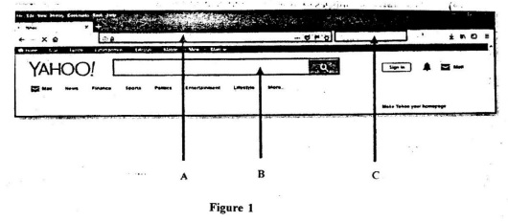
a)

Write the name of the image displayed in Figure 1
b)

List three types of application similar to Figure 1 which can be used to perform the same function as Figure 1 does.
c)

Write the name of the parts labelled A, B and C as shown in Figure 1.
d)

Write two skills to be used to access information from the internet in order to avoid unwanted materials.
e)

State three advantages of using the internet in education

2.
a)

Explain download as used in computing environment.
b)

List three types of information that may be downloaded from a website.
c)

State one advantage of copying a file from a website into an open Word processing application.

3.
a)

Give two examples of a Word processing application.
b)

Complete the table below.
Keyboard shortcut keys | Action performed
Ctrl+A
Ctrl+B
Ctrl+E
 | Italicize selected text
 | Copy selected text
Show Solution
4.
a)

What is an e-mail account?
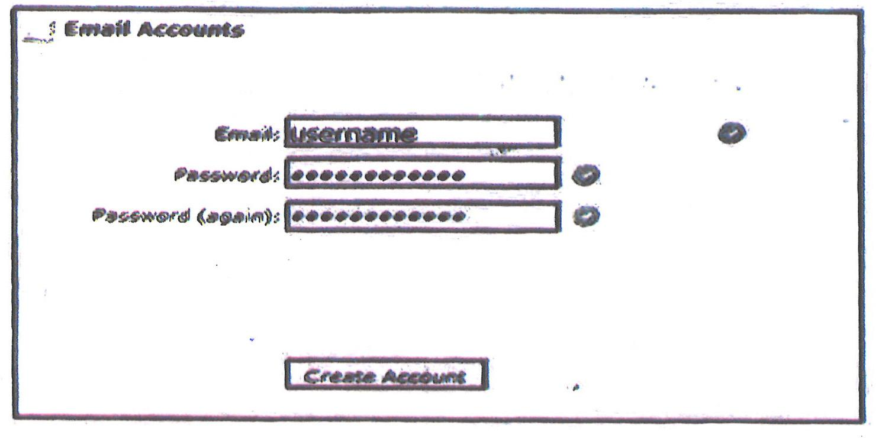
b)

Write a good e-mail address to be typed at where username is shown.
c)

State why the password typed appeared in dots.
d)

Give one reason why the system asked for the password to be typed (again) when creating an e-mail account.

5.
a)

Explain the following terminologies as used in a Spreadsheet application:
i)

cell ..........................................................................................
ii)

cell address ..............................................................................
b)

State two features of an active cell.
i)

....................................................................................
ii)

....................................................................................
c)

State the data type of the data below as used in a Spreadsheet application.
=SUM(B6:H6)

